GRANTS
Policy Number 20
Adoption Date: 25.04.19
Review Date: Annually

Issue Number | Date Agreed | Details of amendments
1 | 25/04/19 | Adopted
2 | 18/07/19 | Changes to grant application form to gather more detailed information about how the organisation supports the village, and how the grant will be used to benefit the village.
3 | 14/05/20 | Updated grant review dates for 2020-21
4 | 08/06/21 | Checked for Accessibility Issues  Reformatted styles where applicable  No changes to the wording of this document have been made
5 | 19/5/2022 | Updated grant review dates for 2022-23
6 | 13/5/2023 | Updated grant review dates for 2023-24
7 | 19/6/2024 | Updated grant review dates for 2024-25

Contents
1. Introduction 2
2. Processing Applications 2
3. Conditions 2
GRANTS – IMPORTANT 4

1. Introduction

A grant is any payment made by the Council to be used by an organisation for a specific purpose that will benefit the Parish, or residents of the Parish, and which is not directly controlled or administered by the Council. The Council awards grants, at its discretion, to Parish organisations which can demonstrate a clear need for financial support to benefit the Parish by:

- Providing a service.
- Enhancing the quality of life.
- Improving the environment.
- Promoting the Parish of Cuckfield in a positive way.
- For running costs of a viable group that is experiencing a period of hardship.
- For hosting special events or celebrations.

2. Processing Applications

- The Clerk to the council will receive all applications in the first instance.
- Applicants will be required to complete an application form unless agreed otherwise by Council.
- All applications must include the most recent copy of their annual accounts (if available).
- Any additional information required by Council prior to making a decision or arising from the application form, should be fully answered and any additional appropriate information provided by the applicant.
- The Council will review grant applications twice a year. For 2024-25, the deadlines for receipt and review are as follows:

Application Deadline Date Application Review Date
13th August 2024 29th August 2024
15th March 2025 3rd April 2025

3. Conditions

- Grant applications will be considered by Full Council.
- The Parish Council will not fund activities outside its powers and functions.
- Grants will not be awarded to individuals.
- Grants will not be made retrospectively.
- Additional applications within a 12-month period will not normally be considered.
- Ongoing commitments to award grants or subsidies in future years will not be made. A fresh application will be required each year.
- Any grant must only be used for the purpose for which it was awarded unless the written approval of the Council has been obtained for a change in use of the grant monies, and that any unspent portion of the grant must be returned to the Council by the end of the financial year in which it was awarded.
- If the group is unable to use the award for the stated purpose, all monies must be returned to the Parish Council.
- All awards must be properly accounted for and evidence of expenditure should be supplied as requested.
- If the Parish Council is not satisfied with the arrangements, they reserve the right to request a refund of monies awarded.
- The policy may be amended at any time by Council following a motion having been published on the agenda beforehand being carried.
- Total Grants awarded in each financial year should not exceed the budgeted amount agreed by Council unless resolved otherwise by Council.

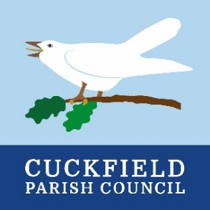

GRANTS – IMPORTANT Documents to send with your application

The following documents MUST be submitted with your application:

- A copy of your organisation’s Constitution, signed and dated by the Chairman.

- If your organisation works with children or vulnerable adults a copy of your Safeguarding Policy and Procedures must be enclosed.

- A copy of your organisation’s audited or independently examined accounts including balance sheet for the past 2 financial years, and a copy bank statement and bank reconciliation as at the last balance sheet date. If your full year accounts are older than 12 months from the date of this application, a signed* interim set of accounts or management accounts will be required also.

- Up to date bank statements of any current and investment accounts.
  - Should there be a severe deterioration between your bank statement at the audit date and an up-to-date statement, this will need to be explained:

- In the case of a newly formed organisation, a budget and business plan should be sent including specification of how the project will be managed.

Please note: the payment of the grant by the Parish Council is made strictly on the understanding that should the project not go ahead; all monies will be returned to the Parish Council.

When completed, please send this form together with supporting documents to:

Sam Heynes
Parish Clerk
Cuckfield Parish Council
The Queen’s Hall
High Street
Cuckfield
West Sussex
RH17 5EL

01444 451610
sam.heynes@cuckfield.gov.uk

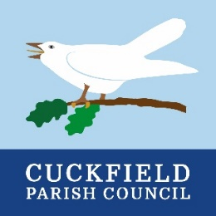

GRANT APPLICATION FORM

Name of Organisation | 4Sight Vision Support
Contact Name and Address | 36 Victoria Drive,  Bognor Regis,  PO21 2TE
Telephone Number | 01243 828 555
Email Address | Julie.branson@4sight.org.uk
Position | Fundraising Manager

Is the Organisation a Registered Charity? | Yes | Yes | No
If yes, please provide Charity Number | 1075447
Amount of grant requested £ | £130.00
What is the nature of your organisation’s activity?
We provide help and support to people across West Sussex who are blind or partially sighted, as well as their family and carers. By proving access to individually tailored support, we help people to retain their independence and not become socially isolated, after receiving a sight loss diagnosis. Our specialist team offers everything from advice on eye health, emotional support, guidance on daily living aids, to assistance with accessible technology. Please see attached letter for more details about the services that we provide.
What are the aims and objectives of your organisation?
Our aim is to enable people to continue leading positive, independent lives, whilst living with sight loss. It is our vision that every person in West Sussex who is living with sight loss is aware of, can access and benefit from our services, so that everyone can experience a life without limits.
When was your organisation formed? |  |  |  |  | 1921
Has it operated previously under another name? |  |  |  |  | Yes |  | Yes | No
If so, when did the change take place? |  |  |  |  | 07/12/2017
Is your organisation part of, or affiliated to, a national organisation? |  |  |  |  | Yes |  |  | No |  | No
If yes, please provide details
What is the catchment area of your organisation? |  |  | The County of West Sussex
How many members belong to your organisation? |  |  |  |  |  | 3,486
Cuckfield Residents | 4 |  |  | Non Cuckfield Residents |  |  |  | 3,482
If your organisation is not membership based, please give details of the number of people you work with/provide services for and how many are resident within Cuckfield |  | We provide support to anyone in West Sussex who is living with sight loss and needs our help, as well as their family and carers. We deliver our specialist services free of charge to our growing membership, which currently stands at 3,486 and 4 of these are living in your parish of Cuckfield.
Briefly describe the project or purpose for which you require a grant |  | We aim to make a positive difference in the lives of people who are living with sight loss, by providing access to support, advice, advocacy and training to improve their quality of life and enable them to retain their independence after a diagnosis.
How will this project benefit the community or residents of Cuckfield? |  | We do not charge our clients for our services, as we do not want there to be a financial barrier to anyone receiving our help and support.  There are currently 4 clients living in your parish of Cuckfield, who will benefit directly from any funding that we receive.
Is your organisation VAT registered? |  |  |  |  | Yes |  |  | No | No
If Yes please write in your VAT number
When do you intend to start the project? |  |  |  |  | Ongoing
Completion Date |  |  |  |  | Funding will be used for the 12 months after it is received
Have you previously received, or applied for, a grant from Cuckfield Parish Council? |  |  |  |  | Yes |  | Yes | No
If YES, please give details of amount(s) and year(s) |  |  |  |  | June 2023 requested £165  received £100  June 2022 requested £150  received £150
Please add any further information in support of your application (additional literature, leaflets or recent annual reports may be enclosed with the application)
Please see attached letter with details of the services we currently provide.

Declaration
I declare that I have read and accept the conditions of the grant and that I have answered all questions fully and truthfully. I also declare that any grant made will be used solely for the purposes outlined in this application. I understand that Cuckfield Parish Council reserves the right to reclaim the grant in the event of it not being used for the purpose specified.

Full Name | Julie Branson
Signed | 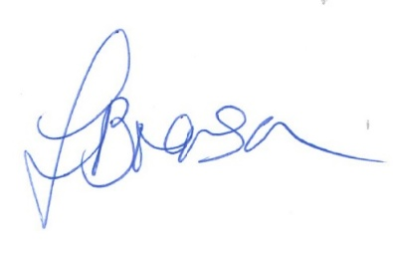
Position | Fundraising Manager
Date | 7th March 2025
Email | Julie.branson@4sight.org.uk

