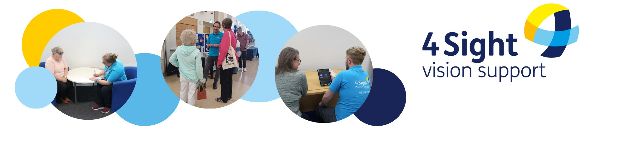**How we have been supporting Cuckfield parish residents who are blind or partially sighted.**

Since the beginning of the financial year (2024/2025) we have supported 4 clients in the parish of Cuckfield. We would like to continue supporting these residents who are blind or partially sighted, and hope that you will look again at our request for support which was submitted to you in March.

Here are some examples of the support our Team have provided:

* Provided advice and demonstrations of specialist pieces of equipment to 2 clients, to ensure they are choosing the most appropriate tools and solutions for their needs.
* Made 2 telephone welfare and advice calls, to check in with our clients.
* Provided support, information and knowledge to 1 client, allowing them to make informed choices and learn to adapt to technology after sight loss.
* Sent all of our clients (who wish to receive it) a newsletter every other month with information, advice and activities that they might find useful, in a choice of accessible formats: audio (CD or USB), Braille, large print, standard print or email.

Clients have been very grateful for our support, here are just a few words of thanks and appreciation:

***“I am so grateful for all the support I have received. I dont know where I’d be without your support....”***

***"you have given me so much more information and hope in the last hour than I have received in the last 6 years"...”***